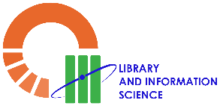**University of Santo Tomas**

**College of Education**

**Bachelor of Library and Information Science Program**

**SAMPLE OF PSYCHOLOGICAL CERTIFICATE**